 | CSE40467 - Data Science  Milestone 1  Prof. Diego Gomez-Zara  TAs: Nandini Banerjee and Colby Nelson

Team Number
Members
Date

Instructions:
- Maximum length: 20 pages, excluding members’ contributions and references.
- Put your responses inside the boxes.
- You can add figures in the boxes.
- Do not alter the font size (11-point), line spacing (1-line), or font typography (Times New Roman).
- References should be added by the end of the document. Use the format that you prefer (e.g., APA, IEEE, ACM, etc.)
- Please do not forget to cite when you make claims or references.

1. Introduction
  - Executive Summary. A good executive summary is a concise and clear overview of a larger document that highlights its key points, findings, and recommendations, aimed at giving readers a quick and comprehensive understanding of its content.
In this project, we investigate the prediction of FIFA Men's World Cup match outcomes as a three-class classification problem: home team win, away team win, or draw. Using 964 matches spanning 22 World Cup tournaments from 1930 to 2022, we engineered 39 features that capture team strength, recent form, head-to-head records, and contextual information, all computed in a leakage-safe manner using only pre-match data. We evaluated seven supervised learning algorithms (K-Nearest Neighbors, Decision Tree, Naive Bayes, Support Vector Machine, Random Forest, Neural Network, and XGBoost) using temporal walk-forward cross-validation, which we found gives significantly more honest performance estimates than standard stratified cross-validation. Our best model, a tuned Random Forest with 300 trees and regularization through minimum leaf size, achieves 62.5% test accuracy and 0.578 macro F1 on the held-out 2022 World Cup, exceeding the 50.0% majority-class baseline by 12.5 percentage points.
Beyond the main model comparison, we conducted an extensive experimental phase in which we tested five external data sources (international match results, FIFA world rankings, qualifying records, squad market values, and StatsBomb expected goals). We found that on our 900-row training set, hyperparameter tuning through regularization delivered roughly four times more improvement than the best feature addition. We also discovered what we call the "overconfidence" pattern, in which more precise team-strength features paradoxically destroy draw prediction by making the model too confident about which team will win.

  - Problem definition. Explain what this problem is about. Discuss why it should be studied/analyzed.
Predicting football match outcomes is a well-studied yet persistently difficult problem in sports analytics. The FIFA Men's World Cup is the most widely watched sporting event globally, and accurate predictions are of interest to researchers, sports analysts, and the general public. We chose this problem for several reasons.
First, football is inherently a low-scoring, high-variance sport where upsets happen frequently. Unlike basketball or baseball, where large scoring margins smooth out randomness, a single goal can decide a football match regardless of which team dominated possession or created more chances. This makes prediction challenging and imposes a natural ceiling on any model's accuracy.
Second, the three-class nature of the target (home win, away win, or draw) adds significant complexity compared to binary classification. Draws are particularly hard to predict because they emerge from many different situations: tactical decisions in group-stage matches where both teams need a point, evenly matched opponents, or fatigue late in a tournament. Published research by Hvattum and Arntzen (2010) reports roughly 53% to 55% accuracy for three-class prediction on international football, which means that even modest improvements above that range represent meaningful progress.
Third, the dataset is small by modern machine learning standards. With only 900 training matches from 22 World Cups held over nearly a century, we face real constraints on model complexity and the number of features we can use before overfitting becomes a concern. This makes the project an instructive case study in how to apply data science techniques when data is scarce and every modeling decision matters.
We believe this problem is worth studying because it highlights fundamental tensions in applied machine learning: the tradeoff between model complexity and data size, the importance of domain-appropriate evaluation (temporal cross-validation versus random splitting), and the surprising finding that more data and more features do not always improve predictions.

2. Related Work
2.1. Describe related work with this data source.
Predicting football match outcomes has been an active research area for several decades. Maher (1982) introduced one of the earliest statistical models, treating goal counts as independent Poisson processes with team-specific attack and defense parameters. His work established the idea that team strength can be decomposed into offensive and defensive components, a principle that influenced our feature design: we include separate goals-scored and goals-conceded features for each team. Dixon and Coles (1997) extended the Poisson model by adding a correlation correction for low-scoring outcomes, which improved draw prediction. Their observation that draws are the hardest outcome to model remains a central challenge in the field, and one we encountered directly in our own experiments.
Hvattum and Arntzen (2010) conducted a systematic evaluation of ELO ratings as predictors for international football. Using over 10,000 matches, they showed that ELO-based ordinal logistic regression achieved roughly 53% to 55% accuracy for three-class prediction. Their work established ELO difference as the single strongest pre-match predictor, a finding that our project independently confirms: in our feature importance analysis, elo_diff consistently ranks as the most important feature.
Hubacek, Sourek, and Zelezny (2019) developed a score-based prediction framework that exploited the ordinal structure of football outcomes (the ordering from away win through draw to home win). Their competitive results in the 2018 Soccer Prediction Challenge suggest that ordinal approaches may offer advantages over standard multiclass classifiers, a direction we note for future work.
Groll, Ley, Schauberger, and Lock (2019) organized a formal prediction tournament for the 2018 World Cup with 26 participating research teams. The best methods combined ensemble learning, hybrid models, and diverse features. A key finding was that no single method dominates; instead, thoughtful feature engineering and honest evaluation matter more than model complexity. Our results align with this: our tuned Random Forest, a relatively straightforward ensemble, outperforms the more complex XGBoost. Additionally, the importance of proper temporal evaluation that Groll et al. highlighted is confirmed by our finding that standard stratified cross-validation overestimates performance by 4 to 9 percentage points compared to temporal walk-forward cross-validation.
In the broader literature on football prediction with machine learning, ensemble methods such as random forests and gradient boosting have been found to consistently outperform simpler models like logistic regression, Naive Bayes, and k-nearest neighbors. Our results are consistent with this pattern: Random Forest and XGBoost were our top two models, while Naive Bayes performed worst. The literature also suggests that combining multiple feature sources tends to improve accuracy; however, our experiments reveal a nuance: on small datasets, additional features can hurt performance through overfitting, a finding with practical implications for how researchers approach feature engineering in data-scarce domains.

3. Data description
3.1. Data Collection. Explain how data collection was conducted. You should explain its origin, context, and purpose, and clearly describe the data source as well as how the data was collected or generated. If your dataset comes from a website, describe the source and explain how the original researchers potentially obtained the data.
Our primary dataset comes from the Fjelstul World Cup Database v1.2.0 (Fjelstul, 2021), a comprehensive open-source database of all FIFA World Cup matches. We used two raw CSV files from this source: matches.csv, which contains all World Cup matches for both men's and women's tournaments, and tournaments.csv, which provides metadata including the year of each tournament. These files were downloaded from the Fjelstul GitHub repository (https://github.com/jfjelstul/worldcup).
After filtering to men's World Cup matches only, the dataset contains 964 matches across 22 tournaments spanning from 1930 to 2022, featuring 84 distinct national teams. Each match record includes 38 columns covering tournament and match identifiers, stage information (group stage or knockout stage), team names and codes, match scores, extra-time and penalty indicators, venue details (stadium name, city, and country), and outcome labels.
For our experimental phase, we additionally integrated five external data sources to test whether they could improve predictions: (1) 49,287 international football match results from 1872 to 2026, sourced from a Kaggle dataset by Mart Jurisoo; (2) 67,894 FIFA world ranking records from 1992 to 2024, obtained from Dato-Futbol on GitHub; (3) Transfermarkt player data consisting of 47,702 player records and 616,377 historical market valuations from 2004 to 2026; (4) 13,843 World Cup squad roster entries from the Fjelstul repository; and (5) 256 team-match event records from StatsBomb open data covering the 2018 and 2022 World Cups.
All data sources are publicly available under open licenses (CC0 Public Domain for the Kaggle datasets, and open access for the others). No web scraping or API access was required; all datasets were downloaded as CSV files.

3.2. Data Preprocessing. Explain all the steps that you performed to transform the raw data into a manageable dataset (e.g., merge, impute missing values, standardize, normalize). If your data did not require any data pre-processing, please discuss any potential quality issues of the data (e.g., how representative is the dataset? Who pre-processed the dataset?)
Our preprocessing pipeline has two main stages: data cleaning and feature engineering.
Data Cleaning (clean_worldcup.py, 173 lines). First, we filter the raw matches file to keep only men's World Cup matches by matching on the tournament name field, and then join with the tournament table to obtain the year column. Second, we perform type cleaning: date columns are parsed using pandas to_datetime with errors='coerce' to safely handle any malformed values; nine boolean-like columns (indicating group stage, knockout stage, extra time, penalties, etc.) are cast from object type to integer using pd.to_numeric with fillna(0) for defensive handling; and six score columns are ensured to be numeric. Third, we split the data by tournament year: matches from 1930 to 2018 form the training set (900 matches), and matches from 2022 form the test set (64 matches). This split simulates the real-world scenario where a model trained on all historical data is used to predict the next World Cup.
Feature Engineering (feature_engineering.py, 1,985 lines). This script concatenates the training and test sets, sorts them chronologically, and computes 39 features. A critical design decision is the use of a date-level shift rather than a row-level shift when computing expanding-window features. Because multiple World Cup matches can occur on the same day, a row-level shift could allow same-day results to leak into features. Our date-level shift prevents this. After computing all features, missing values are filled with principled defaults (described in the Variables section), and the data is split back into separate training and test CSV files. Post-match columns such as scores and outcomes are explicitly excluded from the output to prevent accidental leakage.
Missing Value Strategy. Rate features (win rate, draw rate) receive a fill value of 0.33, representing a uniform prior for the three-class problem. Count features (matches played, appearances) receive 0 to indicate no prior history. ELO ratings start at 1500 (the standard initial value). Rest days are filled with the median of existing values. Interaction features are filled with 0.0, consistent with the zero-filled components they are derived from.

3.3. Data Documentation. Please include a clear and comprehensive description of your dataset with descriptive statistics. In addition, explicitly state any assumptions, limitations, and preprocessing decisions you made. Your documentation should provide enough detail for someone else to fully understand the dataset and reproduce your work.
The cleaned dataset consists of 964 matches with 38 raw columns per match. The training set contains 900 matches from 21 tournaments (1930 to 2018), and the test set contains 64 matches from the 2022 Qatar World Cup. There are 84 distinct national teams across the full dataset. A detailed codebook documenting every column is maintained in docs/worldcup_subset_codebook.csv.
Key descriptive statistics. Home teams score an average of 1.78 goals per match compared to 1.05 for away teams. There are no null values in the cleaned dataset. The raw columns include: tournament_id and match_id (identifiers), group_stage and knockout_stage (binary indicators), stage_name (text label for the round), home_team_name and away_team_name, team codes, home_team_score and away_team_score, extra_time and penalty indicators, stadium_name, city_name, country_name, and the outcome labels (result, home_team_win, away_team_win, draw).
Target variable distribution. The target is "result" with three classes. In the training set: home team win appears 513 times (57.0%), away team win appears 218 times (24.2%), and draw appears 169 times (18.8%). In the test set, the distribution is more balanced: 32 home wins (50.0%), 16 away wins (25.0%), and 16 draws (25.0%). This distributional shift between training and test is notable because models that heavily exploit the home-win prior will be penalized on the more balanced 2022 test set.
Important domain note. The "home team" designation in World Cup matches is a FIFA administrative assignment at a neutral venue, not a true home advantage as in domestic league matches. This is a key nuance of the dataset that our home_is_host and continent advantage features attempt to address.
After feature engineering, the final processed dataset has 39 features plus metadata and target columns per match.
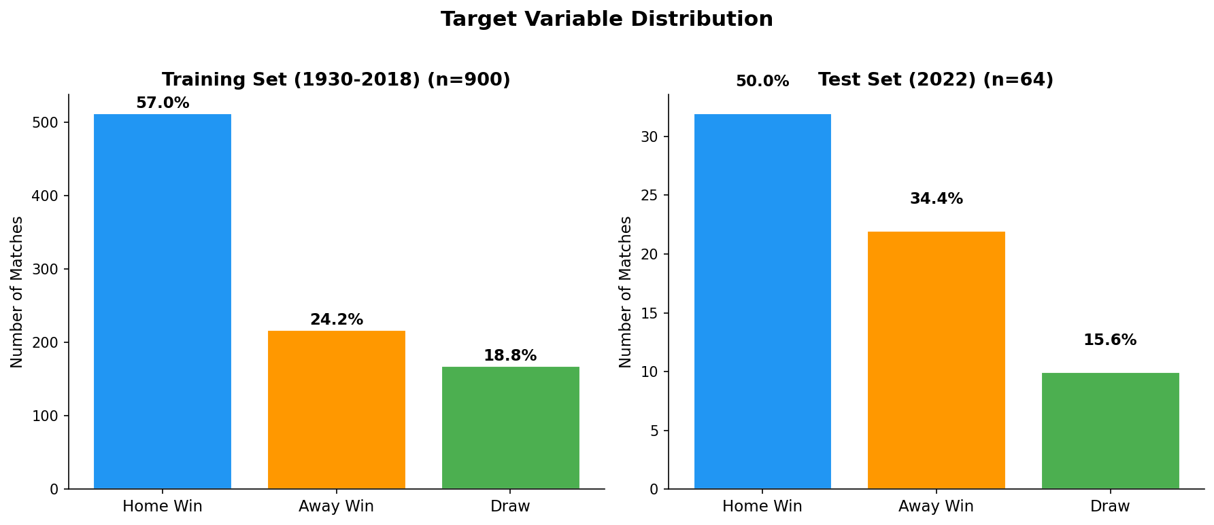

3.4. Variables. Describe which columns are features (independent variables) and which ones are your target/class/dependent variables.
Target variable (dependent variable). The target is "result," a three-class categorical variable indicating the match outcome: home team win, away team win, or draw.
Feature variables (independent variables). Our model uses 39 engineered features organized into 10 categories, all computed using only information available before each match:
(A) Team Historical Performance (12 features): cumulative win rate, draw rate, goals per game, goals conceded per game, and total matches played for both home and away teams, plus difference features for win rate and goals. These use expanding-window aggregates over all prior World Cup matches.
(B) Match Context (3 features): binary indicators for group stage and knockout stage, plus an ordinal encoding of the tournament stage (group = 0 through final = 6).
(C) Host Advantage (2 features): binary flags for whether the home or away team is the tournament host nation.
(D) World Cup Experience (3 features): count of distinct prior World Cup tournaments each team appeared in, plus their difference.
(E) Head-to-Head Record (5 features): total prior World Cup meetings between the two teams, wins for each side, draws, and the home team's win rate in those meetings (defaulting to 0.33 for first-time matchups).
(F) ELO Ratings (3 features): pre-match ELO for each team (all teams start at 1500, K-factor of 32) and their difference. Computed from World Cup matches only.
(G) Rolling Form (4 features): win rate and goals per game over each team's last 5 World Cup matches, with fallbacks for teams with fewer prior matches.
(H) Rest Days (2 features): days since each team's previous World Cup match, capped at 365.
(I) Interaction Features (3 features): home attack multiplied by away defense, away attack multiplied by home defense, and ELO difference multiplied by rolling form difference. These capture non-linear relationships.
(J) Home Continent Advantage (2 features): binary flags indicating whether each team's FIFA confederation matches the host country's confederation. This captures the documented effect that European teams win over 60% of World Cup matches played in Europe, and similarly for South American teams at South American World Cups.

4. Modeling
4.1. Description of Algorithm 1 and its model. Please include details about the parameters. Did you fine-tune the parameters?
Algorithm 1: Random Forest (Best Model)
Our best-performing model is a Random Forest classifier, an ensemble method that aggregates predictions from many decision trees, each trained on a bootstrap sample of the data. We chose Random Forest as our primary model because bagging-based ensembles are effective at reducing variance, which is particularly important on our small 900-row dataset where individual trees tend to overfit.
Final hyperparameters: n_estimators = 300 (number of trees), max_features = 'sqrt' (number of features considered at each split), min_samples_leaf = 5 (minimum samples required in a terminal node), and class_weight = 'balanced' (class weights inversely proportional to frequency).
Hyperparameter tuning process. We determined these parameters through a grid search using 4-fold temporal walk-forward cross-validation. The search explored n_estimators in {100, 200, 300, 500}, max_features in {0.2, 0.3, 'sqrt', 'log2'}, and min_samples_leaf in {1, 3, 5}. The most impactful parameter was min_samples_leaf: increasing it from the default of 1 to 5 improved cross-validation F1 from 0.488 to 0.531, a gain of 4.3 percentage points. This was the single largest improvement in the entire project, exceeding the benefit of any feature addition. It works by preventing the model from creating terminal nodes that memorize noise in small subsets of the training data, effectively acting as regularization.
Class imbalance handling. The class_weight = 'balanced' setting addresses the imbalance in our training data (57% home wins, 24% away wins, 19% draws) by assigning higher weight to underrepresented classes. Without this, the model tends to ignore the minority draw class almost entirely.
Results: test accuracy of 62.5%, test macro F1 of 0.578, test RPS of 0.133, and temporal cross-validation F1 of 0.541. The top features by importance are elo_diff, home_elo, away_elo, elo_x_form_diff, hist_win_rate_diff, and home_hist_win_rate.

4.2. Description of Algorithm 2 and its model. Please include details about the parameters. Did you fine-tune the parameters?
Algorithm 2: XGBoost (Extreme Gradient Boosting)
XGBoost is our second model, chosen because it represents a fundamentally different ensemble strategy from Random Forest. While Random Forest uses bagging (training independent trees on bootstrap samples and averaging them), XGBoost uses boosting: it builds trees sequentially, with each new tree correcting the errors of the previous ones through gradient descent on a loss function. We wanted to test whether this sequential error-correction approach would outperform the parallel averaging of Random Forest on our dataset.
Hyperparameters. We tested three configurations via temporal cross-validation, varying max_depth (3, 4, 5), n_estimators (100, 150, 200), and learning_rate (0.05, 0.08, 0.1). We applied L1 and L2 regularization (reg_alpha = 0.5, reg_lambda = 2.0) to control overfitting and gave draws 1.5 times sample weight to address the class imbalance.
Results and comparison with Random Forest. XGBoost achieved a test accuracy of 59.4% and macro F1 of 0.514, compared to Random Forest's 62.5% and 0.578. The temporal cross-validation F1 was 0.434 versus Random Forest's 0.541. We believe this underperformance is primarily a dataset size effect. Boosting methods generally need larger training sets to realize their advantages because each sequential tree has to learn meaningful residual patterns from the previous trees' errors. With only 900 training rows, the residual patterns tend to be dominated by noise rather than genuine signal. Random Forest's variance reduction through averaging many independent trees proves more effective at this scale. This finding is consistent with the general observation in the machine learning literature that bagging tends to outperform boosting on smaller datasets.

4.3. Description of Algorithm 3 and its model. Please include details about the parameters. Did you fine-tune the parameters?
Algorithm 3: Five Additional Models
We evaluated five more algorithms to provide a comprehensive comparison across different modeling paradigms.
K-Nearest Neighbors (KNN). KNN is a non-parametric method that classifies each match by majority vote among its k nearest neighbors in feature space. We tuned k over {3, 5, 7, 9} using temporal cross-validation. As a distance-based method, it benefits from the StandardScaler normalization we applied. KNN serves as a simple baseline that makes no assumptions about the data distribution. It achieved 53.1% test accuracy and 0.463 macro F1.
Decision Tree. A single decision tree with max_depth tuned over {3, 5, 7, 10, None}. We included it primarily for its interpretability and the feature importance rankings it produces, which helped us understand what information drives predictions. Its analysis confirmed elo_diff as the top predictor. Test accuracy: 51.6%, test F1: 0.469.
Gaussian Naive Bayes. This probabilistic method assumes that features are conditionally independent given the class label. We included it knowing this assumption is violated by our correlated features (for example, home_elo and home_hist_win_rate both measure team strength). It performed worst of all models with 32.8% test accuracy and 0.316 macro F1, even below the majority-class baseline, demonstrating the cost of the independence assumption when features carry overlapping information.
SVM with RBF Kernel. We tuned the regularization parameter C over {0.1, 1, 10, 100} using temporal cross-validation and set class_weight = 'balanced.' SVM achieved 51.6% test accuracy and 0.392 F1. Notably, it had the second-best RPS (0.139), suggesting that its predicted probabilities are reasonably well-calibrated even when its point predictions are not the most accurate.
Neural Network (MLP). A multi-layer perceptron with two hidden layers of 64 and 32 neurons, early stopping, and a maximum of 500 iterations. It achieved 51.6% test accuracy and 0.415 F1. The MLP showed considerable instability: its temporal cross-validation accuracy was only 41.1%, much lower than its test accuracy of 51.6%. This variability suggests that 900 training samples is not enough for neural networks to learn stable patterns, even with early stopping as regularization.

5. Evaluation
5.1. Baseline. Please describe your baseline for the evaluation.
Our baseline is the majority-class classifier, which always predicts "home team win" regardless of any match information. Since home team wins account for 57.0% of the training data, this baseline achieves 57.0% accuracy on the training set. On the 2022 test set, where the distribution is more balanced (50.0% home wins, 25.0% away wins, 25.0% draws), the baseline achieves 50.0% accuracy.
We chose this baseline because it represents the simplest possible prediction strategy and sets a meaningful bar that any useful model must exceed. It is more demanding than a random classifier (which would achieve roughly 33.3% on a balanced three-class problem) and better reflects what a naive human predictor might do: simply guess that the stronger team (as indicated by FIFA's "home" label) will win.
Our best model, the tuned Random Forest, surpasses this baseline by 12.5 percentage points on the test set (62.5% versus 50.0%), demonstrating that the features we engineered carry genuine predictive signal beyond what a naive majority prediction offers.

5.2. Metrics. Describe the metrics and their results.
We used three primary metrics to evaluate all models, along with confusion matrices and per-class classification reports.
Accuracy measures the fraction of correct predictions. While intuitive, it can be misleading on imbalanced datasets, since a model that ignores minority classes can still appear accurate.
Macro F1 is the unweighted average of per-class F1 scores. It penalizes models that perform poorly on any class, making it our most informative single metric for this imbalanced three-class problem. A model that achieves high accuracy by ignoring draws would receive a low macro F1.
Ranked Probability Score (RPS) measures the quality of predicted probability distributions assuming an ordinal ordering (away win < draw < home win). Lower is better. This metric is standard in sports forecasting and evaluates whether a model's confidence is well-calibrated, not just whether its top prediction is correct.
Results on the 2022 World Cup test set (64 matches):
Random Forest (tuned): 62.5% accuracy, 0.578 F1, 0.133 RPS (best on all three metrics).
XGBoost: 59.4% accuracy, 0.514 F1, 0.146 RPS.
KNN: 53.1% accuracy, 0.463 F1, 0.158 RPS.
Decision Tree: 51.6% accuracy, 0.469 F1, 0.165 RPS.
SVM (RBF): 51.6% accuracy, 0.392 F1, 0.139 RPS.
Neural Network: 51.6% accuracy, 0.415 F1, 0.148 RPS.
Naive Bayes: 32.8% accuracy, 0.316 F1, 0.253 RPS.
Under temporal cross-validation, every model showed 4 to 9 percentage points lower accuracy compared to standard stratified cross-validation. This confirms that shuffled cross-validation overestimates performance on temporal sports data by allowing the model to train on future tournaments and validate on past ones.
The best model's draw recall was approximately 44% in cross-validation, consistent with published findings that draws are the hardest outcome to predict. The top features by Random Forest importance were elo_diff, home_elo, away_elo, and elo_x_form_diff.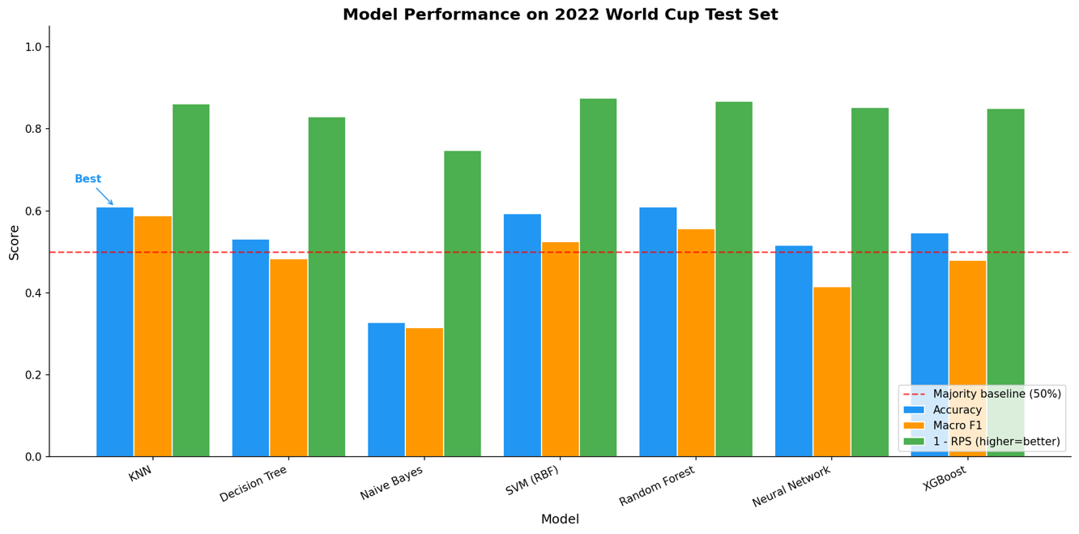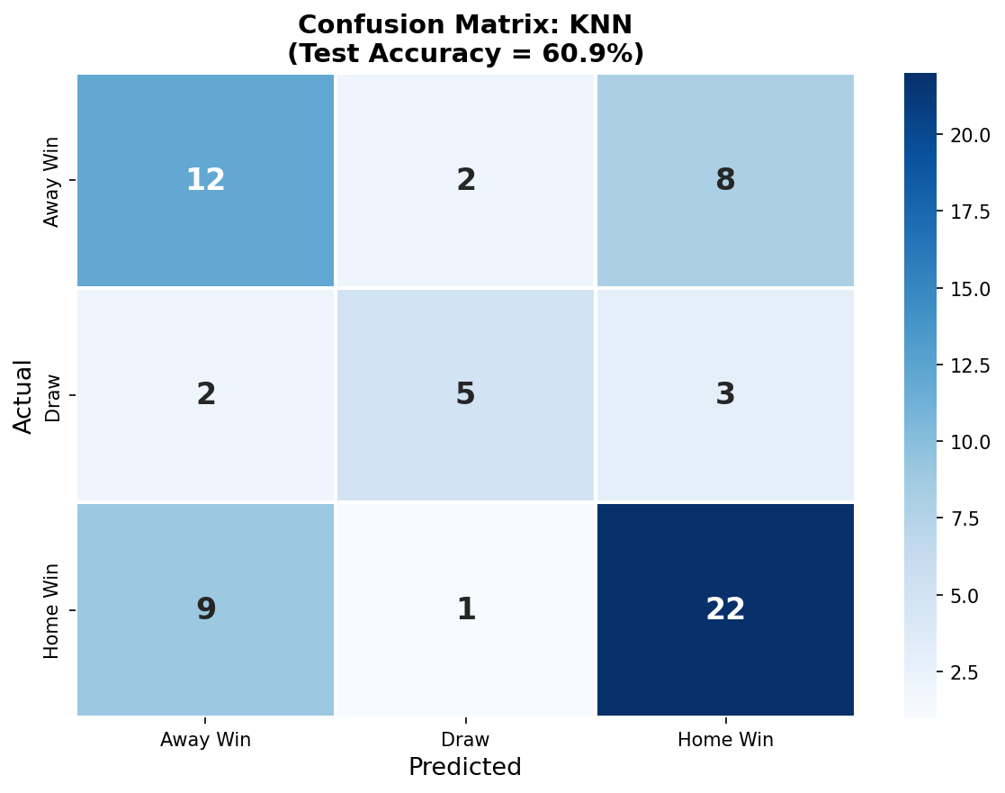

6. Discussion
6.1. Discussion of the Results. Please provide a thorough and insightful analysis of the results, integrating them with previous/related work.
Our tuned Random Forest with 39 features achieves 62.5% test accuracy and 0.578 macro F1 on the 2022 World Cup. The temporal cross-validation F1 of 0.541, computed across roughly 256 validation matches from four tournament-year folds, gives a more stable performance estimate. Both numbers are competitive with published benchmarks of 53% to 55% accuracy for three-class international football prediction (Hvattum and Arntzen, 2010). We note that our 64-match test set carries high variance: a single upset can shift accuracy by about 1.5 percentage points.
The value of regularization over feature engineering. The most impactful improvement in our project came not from adding features or data, but from regularization. Increasing min_samples_leaf from 1 to 5 improved cross-validation F1 by 4.3 percentage points, roughly four times more than the best feature addition (continent advantage at 1.0 percentage point). This tells us that on a 900-row dataset, the model was overfitting to noise rather than lacking information. This result connects to the bias-variance tradeoff: on small datasets, reducing model complexity tends to be more effective than adding new signals.
The "overconfidence" pattern. We discovered that features which more precisely measure team strength (such as international ELO, FIFA ranking points, and squad market values) paradoxically hurt the model. These features make the model confident in predicting a winner and cause it to stop predicting draws entirely, which collapses the macro F1 score. Our World Cup-only ELO system, which updates only every four years, creates what we term "productive imprecision": when many teams enter a tournament with similar ratings, the model treats draws as plausible outcomes. This finding relates to Dixon and Coles' (1997) observation about the difficulty of draw prediction and suggests that some degree of feature imprecision can actually be beneficial in small-sample classification.
Domain mismatch in expanded training. We attempted to expand our training from 900 World Cup matches to 28,000 international matches, expecting that more data would help. Instead, every configuration performed worse. The reason is a fundamental domain mismatch: in qualifying matches and friendlies, the "home team" plays at their actual stadium with a roughly 60% win rate, but in World Cup matches, "home team" is a FIFA administrative label at a neutral venue with a roughly 50% win rate. The model learned a home-win bias from non-World Cup data that does not apply to the tournament. This illustrates an important lesson: more data is not always better when the additional data comes from a different distribution.
Temporal cross-validation as essential methodology. Every model we tested showed 4 to 9 percentage points lower accuracy under temporal walk-forward cross-validation compared to standard stratified cross-validation. This gap confirms that shuffled cross-validation creates temporal information leakage in sports prediction. We recommend temporal cross-validation as the primary evaluation method for any time-series or sports prediction problem.
Unsupervised analysis. PCA shows that roughly 15 of 37 principal components explain 90% of variance, indicating that our features capture diverse, non-redundant information. K-Means clustering with k = 3 produced an Adjusted Rand Index of only 0.022 against actual outcome labels, confirming that match outcomes do not form easily separable clusters in feature space. This underscores the inherent difficulty of the prediction task.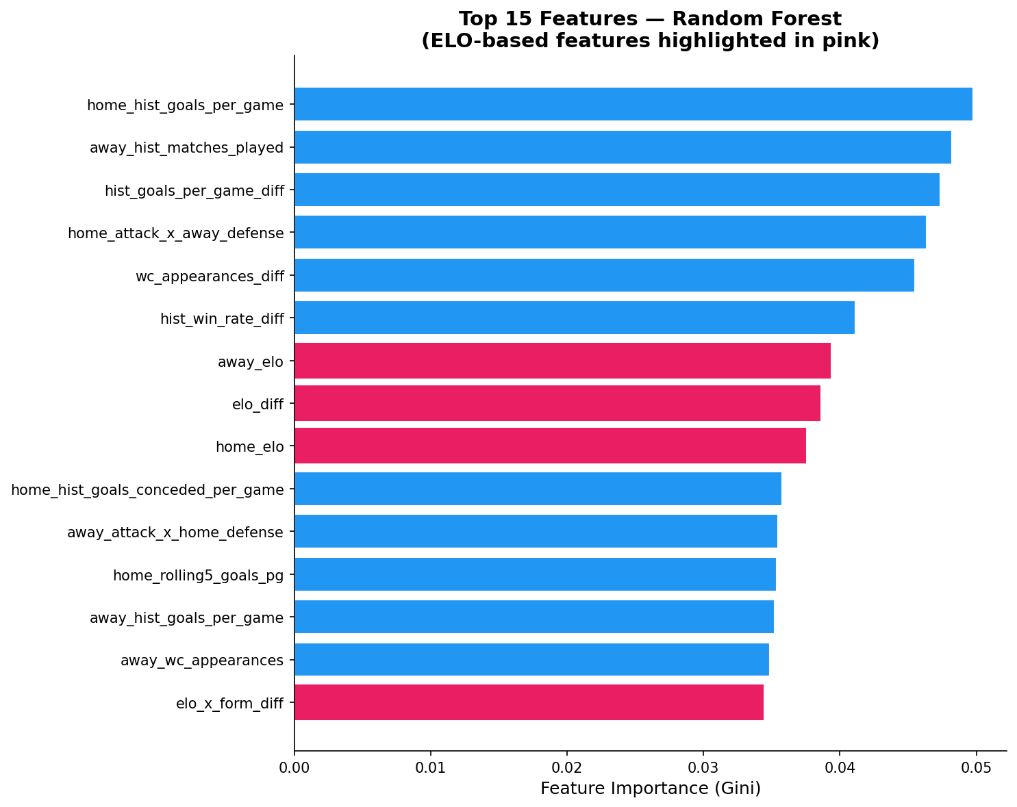
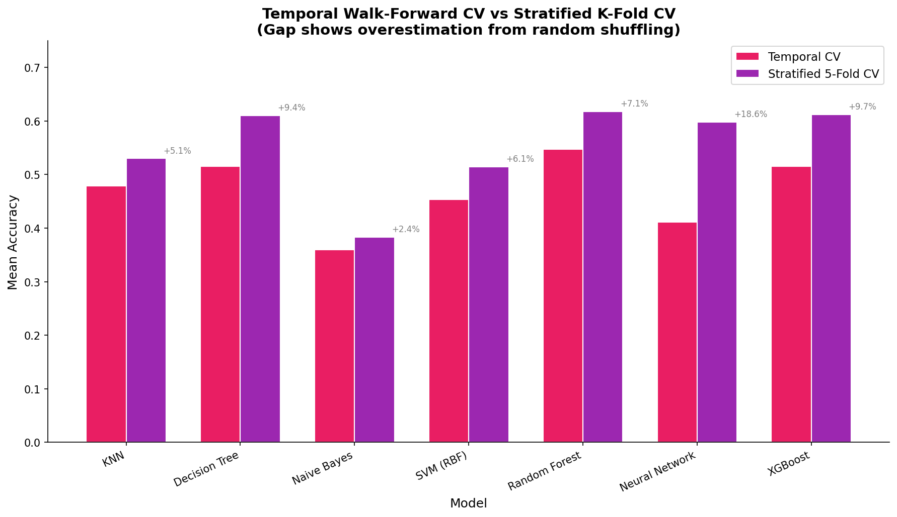

6.2. Recommendations and implications of your report. Provide relevant recommendations, develop thoughtful implications, and suggest specific actionable directions for the future.
Based on our findings, we offer several recommendations and directions for future work.
1. Incorporate betting odds as a feature or calibration target. Pre-match betting odds from the sports betting market aggregate large amounts of public information about team form, injuries, and tactical matchups. Published research (Groll et al., 2019) has shown that odds-based features are among the strongest predictors for football match outcomes. Adding this as a feature could push accuracy beyond what ELO-based features alone can achieve.
2. Explore ordinal regression. Football outcomes have a natural ordering (away win, draw, home win), and our current models treat them as unordered categories. Methods that exploit this ordinal structure, such as the approach by Hubacek et al. (2019), might improve draw prediction by treating it as an intermediate outcome rather than an independent class.
3. Prioritize regularization before feature engineering on small datasets. Our finding that regularization outperforms feature engineering by a factor of four has practical implications beyond this project. For any prediction problem with limited training data, practitioners should first tune model complexity (minimum leaf size, maximum depth, or regularization penalties) before investing effort in gathering additional feature sources. Our experiments suggest that the "feature budget" on 900 rows is roughly 37 to 39 features, and going beyond that threshold causes more harm than benefit through overfitting.
4. Revisit expected goals with broader coverage. Among the five external feature sources we tested, StatsBomb's expected goals had the lowest correlation with ELO (r = 0.35) and captured genuinely novel information about match quality rather than team strength. It failed in our experiments solely due to limited coverage (only 10% of training data had real values). If event-level data becomes available for additional World Cups beyond 2018 and 2022, this feature could be a valuable addition.
5. Develop a more sophisticated ELO integration. Our World Cup-only ELO creates productive imprecision that helps draw prediction, but computing ELO from all international matches with a variable K-factor (weighting World Cup matches more heavily) could potentially capture both benefits: the richer update frequency of international data and the domain specificity of World Cup matches. This would require careful handling of the domain mismatch issue we identified.
Broader implications. Our project shows that in applied prediction tasks with small datasets, model regularization and domain-specific evaluation methodology matter more than sophisticated features or complex algorithms. The "overconfidence" pattern we identified, in which precise features hurt minority-class prediction, may apply to other imbalanced classification tasks in domains such as medical diagnosis or fraud detection, where minority classes are both rare and practically important.

7. Code and Data Availability
Please provide the link to your GitHub repository here:
https://github.com/drdiguglielmo-personal/datascienceproject

7. Members’ Contributions
You must describe what each member contributed to this report. We will adopt the CRediT Taxonomy to describe each team member’s individual contributions. The submitting team member is responsible for providing the contributions of all authors at submission. We expect that all team members will have reviewed, discussed, and agreed to their individual contributions ahead of this time.

Contributor Role | Role Definition | Team Members  (List your names here)
Conceptualization | Ideas; formulation or evolution of overarching research goals and aims.
Data Collection | Activities to search for, obtain, download datasets.
Data Curation | Management activities to annotate (produce metadata), scrub data and maintain research data (including software code, where it is necessary for interpreting the data itself) for initial use and later reuse.
Formal Analysis | Application of statistical, mathematical, computational, or other formal techniques to analyze or synthesize study data.
Investigation | Conducting a research and investigation process, specifically performing the experiments, or data/evidence collection.
Methodology | Development or design of methodology; creation of models
Project Administration | Management and coordination responsibility for the research activity planning and execution.
Software | Programming, software development; designing computer programs; implementation of the computer code and supporting algorithms; testing of existing code components.
Validation | Verification, whether as a part of the activity or separate, of the overall replication/reproducibility of results/experiments and other research outputs.
Visualization | Preparation, creation and/or presentation of the published work, specifically visualization/data presentation.
Writing – Original Draft Preparation | Creation and/or presentation of the published work, specifically writing the initial draft (including substantive translation).
Writing – Review & Editing | Preparation, creation and/or presentation of the published work by those from the original research group, specifically critical review, commentary or revision – including pre- or post-publication stages.

References
Dixon, M. J., and Coles, S. G. (1997). Modelling association football scores and inefficiencies in the football betting market. Journal of the Royal Statistical Society: Series C (Applied Statistics), 46(2), 265-280.
Fjelstul, J. C. (2021). The Fjelstul World Cup Database v1.2.0. https://github.com/jfjelstul/worldcup
Groll, A., Ley, C., Schauberger, G., and Lock, H. (2019). A hybrid random forest to predict soccer matches in national and international tournaments. Journal of Quantitative Analysis in Sports, 15(4), 271-287.
Hubacek, O., Sourek, G., and Zelezny, F. (2019). Exploiting sports-betting market using machine learning. International Journal of Forecasting, 35(2), 783-796.
Hvattum, L. M., and Arntzen, H. (2010). Using ELO ratings for match result prediction in association football. International Journal of Forecasting, 26(3), 460-470.
Maher, M. J. (1982). Modelling association football scores. Statistica Neerlandica, 36(3), 109-118.

